EXPERIMENT NO : 07

Title

To create and deploy a simple 'Hello World' web application using Google App Engine with both Python and Java environments.

Theory

Google App Engine (GAE) is a Platform-as-a-Service (PaaS) offering from Google Cloud that enables developers to build and deploy web applications without managing servers or infrastructure. It provides automatic scaling, monitoring, and integrated support for multiple programming languages such as Python, Java, Go, PHP, and Node.js.
Developers use configuration files such as app.yaml to define runtime environments and manage deployment settings. Google Cloud SDK provides the gcloud command-line tool used for deploying and managing App Engine applications.
Key Features of Google App Engine:
• Automatic scaling based on traffic.
• Multi-language support (Python, Java, Go, PHP, etc.).
• Built-in monitoring and logging.
• Fully managed infrastructure.

Procedure
The following steps were followed to create and deploy the web application using Google App Engine:
- Installed Google Cloud SDK from the official Google website.

- Initialized the SDK using the command `gcloud init` and logged in with Google credentials.
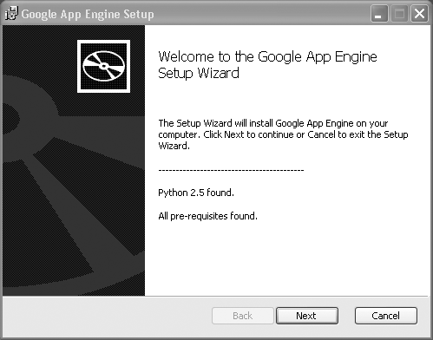

3. Installed App Engine components using:
- - For Python: `gcloud components install app-engine-python`
- - For Java: `gcloud components install app-engine-java`

Part A: Creating a Python Web Application
4. Created a project directory named `hello-world-python`.
5. Inside the folder, created a file named main.py with the following code:
from flask import Flask
app = Flask(__name__)
@app.route('/')
def hello():
return "Hello, World from Python App Engine!"
if __name__ == '__main__':
app.run(host='0.0.0.0', port=8080, debug=True)
6. Created a requirements.txt file with dependencies:
- Flask==2.3.2
- gunicorn==20.1.0
7. Created the configuration file app.yaml with the following content:
runtime: python310
entrypoint: gunicorn -b :$PORT main:app
handlers:
- url: /.*
script: auto
8. Installed dependencies using `pip install -r requirements.txt`.
9. Ran the Flask application locally using `python main.py`.
10. Opened the application at http://localhost:8080 and verified the output:
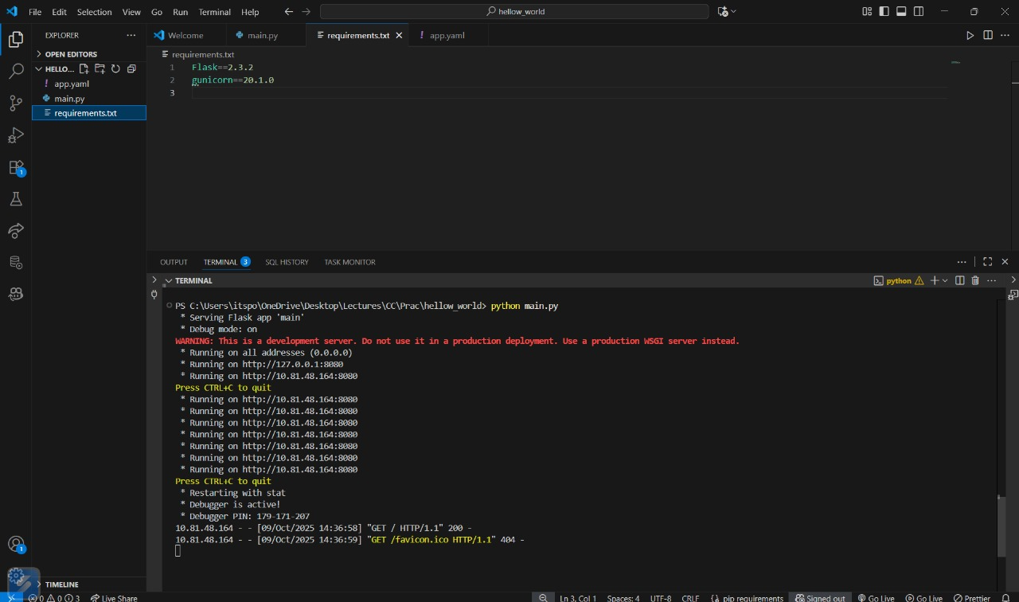

Part B: Deploying the Application
11. Logged into Google Cloud using `gcloud auth login`.
12. Set the default project using `gcloud config set project YOUR_PROJECT_ID`.
13. Deployed the app using `gcloud app deploy`.
14. Opened the deployed application in a browser using `gcloud app browse`.
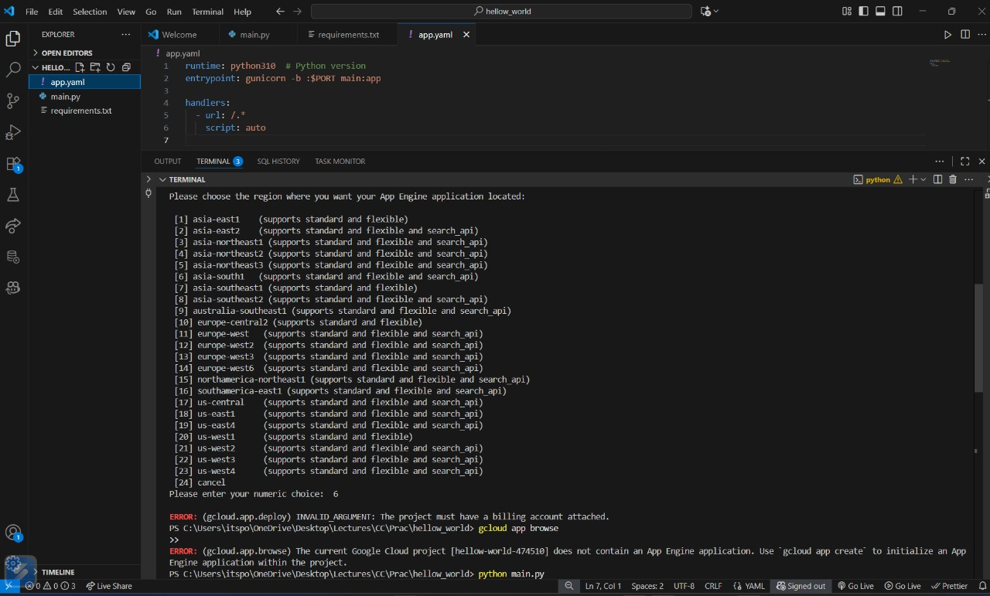

Output / Result

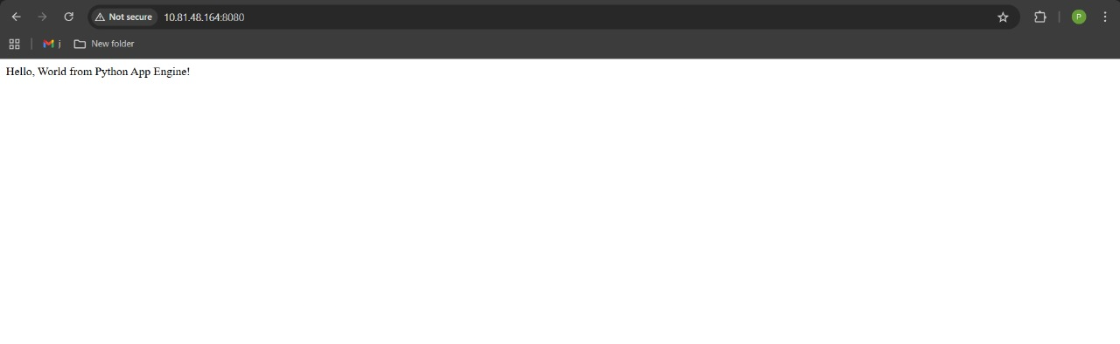

Output in Browser

Conclusion
A simple web application was successfully created and deployed using Google App Engine with Python and Java runtimes. The practical demonstrated how to configure runtime files, install dependencies, and use Google Cloud SDK to deploy applications seamlessly on the cloud platform.

